Title of abstract in Arial font: size 14, centered

First Author¹, Second Author² and Third Author²
Author 1 affiliation, Country¹
Author 2 affiliation, Country²
Author 3 affiliation, Country³

E-mail: First.Author@xxmail.com

ABSTRACT
The extended abstract of your paper should be written in a structured manner within two pages limit. The abstract should be written in a single-paragraph format. An abstract is a paragraph summary of the paper you will give at the conference. A good abstract should give a brief overview of the paper including the purpose, the research design/methodology, and the main findings. It is also a good practice to explain how the findings from the research can be useful in solving problems or closing gaps in the specific subject area. The submitted abstract should be either a Microsoft Office Word file (*.doc,*.docx) or a .pdf file. Please do not use symbols, special characters, footnotes, or math in Paper Title of Abstract.

KEYWORDS: The author shall provide up to 6 keywords (in alphabetical order) to help identify the major topics of the paper. (max 6 key words in English)

INTRODUCTION
Use Times New Roman 10. Do not indent the first line of paragraph following a heading or subheading. Use single spacing for main document. According to Islam & Soares (2023) that there is only one space between sentences. Use single spacing for main document. Note that there is only one space between sentences. Use single spacing for main document. Note that there is only one space between sentences (Kong et al. 2019).

Include background of the study, current limitation or research gaps to be solved, objective, and scope of the study. Use Times New Roman 10. Do not indent the first line of paragraph following a heading or subheading. Use single spacing for main document. According to Ali et al. (2024) that there is only one space between sentences. Use the following format for Eq. (1).

$$\frac{v (t)}{s}= α$$ | (1)

RESULTS AND DISCUSSION
As shown in Table 1, use Times New Roman 9 for table caption. Follow the table format and explain the table in the main text before introducing the table.

Table 1 Include with captions Font Times New Roman 8
Heading | Heading
Item 1 | Details 1
Item 2 | Details 2
Item 4 | Details 3

As shown in Fig. 1, use Times New Roman 9 for figure caption. Ensure that each figure has a caption placed below it and refer to and explain the figure in the main text prior to its placement.

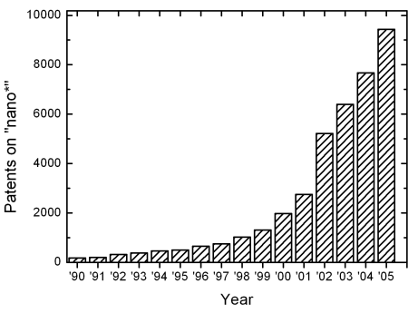
(a)
(b)
Fig. 1 Include with captions: (a) font Times New Roman, (b) font size should be 8

CONCLUSION
Use Times New Roman 10. Do not indent the first line of paragraph following a heading or sub heading. Use single spacing for main document. Note that there is only one space between sentences. Use single spacing for main document. Note that there is only one space between sentences. Use Times New Roman 10. Do not indent the first line of paragraph following a heading or sub heading. Use single spacing for main document. Note that there is only one space between sentences. Use single spacing for main document. Note that there is only one space between sentences.

References
The references inserted in the text and the list of references must meet APA standards (American Psychological Association 7th edition- more information http://www.apastyle.org/). Simple example of a references;

(Book style - Author, year. Title (in italics). Publisher, location of publisher.)
Cichocki, A. and Unbehaven, R., (1993). Neural Networks for Optimization and Signal Processing, 1st ed. Chichester, U.K.: Wiley.
Chen, W. K. (1993). Linear Networks and Systems, Belmont, CA: Wadsworth, pp. 123-135.
(Journal - Author, year. Paper title. Journal name (in italics), volume and issue numbers, inclusive pages.)
Chen, S., Mulgrew, B. and Granta, P. M. (1993). “A clustering technique for digital communications channel equalization using radial basis function networks,” IEEE Trans. on Neural Networks, vol. 4, pp. 570-578.
Hill, R. M. (1997). The single-vendor single-buyer integrated production–inventory model with a generalized policy, European Journal of Operational Research, vol. 97, pp. 493-499.
(Online Sources style)
Vidmar, R. J. (August 1992). On the use of atmospheric plasmas as electromagnetic reflectors. IEEE Trans. Plasma Sci. [Online]. 21(3). pp. 876-880. Available: http://www.halcyon.com/pub/journals/21ps03-vidmar
(Conference paper or contributed volume - Author, year, paper title. Proceedings title (in italics). City, country, inclusive pages.)
Beck, K. and Ralph, J. (1994). Patterns Generates Architectures. Proceedings of European Conference of Object-Oriented Programming. Bologna, Italy, pp. 139-149.

ACKNOWLEDGEMENT
Sponsorship and financial support acknowledgments should be included here. If no acknowledgement is necessary, this section should not appear.

